

100 DAYS RTL PART-1

Day 61: LOGIC DATATYPE

Day 62: UNPACKED STRUCT DATATYPE

Day 63: PACKED STRUCT DATATYPE

Day 64: ARRAY

Day 65: FUNCTION

Day 66: TASKS

Day 67: INTERFACE

Day 68: INHERITANCE

Day 69: POLYMORPHISM

Day 70: PARAMETERIZED CLASS

Day 61: Logic Datatype
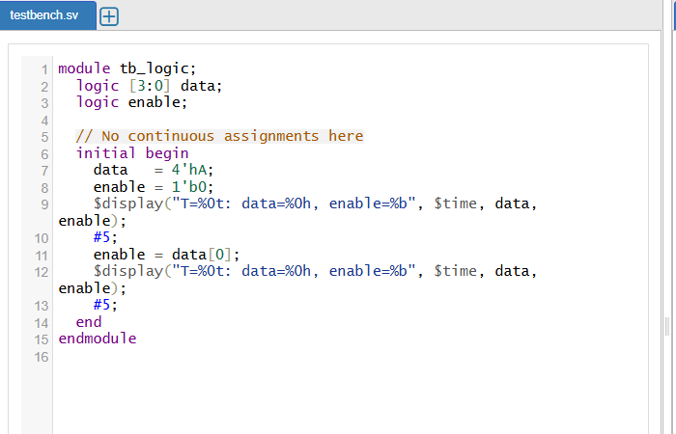
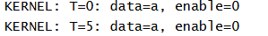
🧠 1. 4-State vs. 2-State Logic
- 4-state variables (logic, legacy reg, wire) can represent 0, 1, X (unknown), and Z (high-impedance). This models real hardware scenarios like uninitialized signals or tri-state buses
- 2-state types (bit, int, etc.) only hold 0 or 1, enabling faster simulation when X/Z semantics aren’t needed.

2. logic Replaces reg and wire
- logic is a universal 4-state data type that can be assigned in both procedural blocks (initial/always) and continuous assignments (assign)
- This obsoletes Verilog’s confusing duality of wire (nets, continuous only) and reg (procedural storage only), offering a simpler, unified alternative
3. Driver Rules & Multiple Sources
- A signal declared as logic must have a single driver. If multiple drivers are needed (like a multiplexer or tri-state bus), use a net (wire) so the tool can resolve and arbitrate based on driver strengths
Day 62: Unpacked Struct Datatype
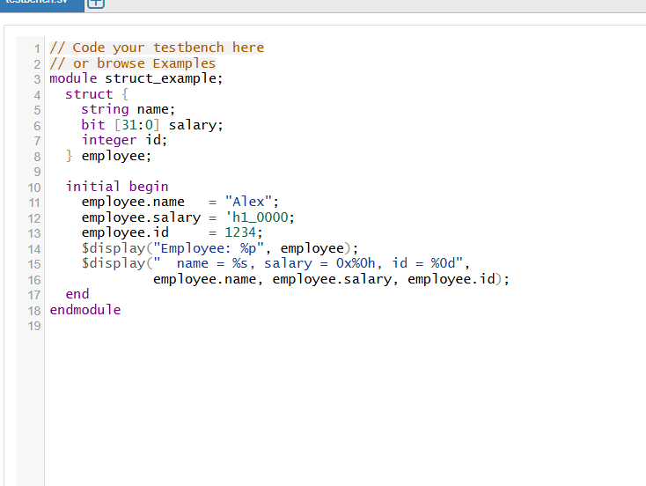

What’s an unpacked struct?
A struct is a grouping of variables (members) of different data types into one composite type.
- Unpacked means each instance is stored separately and may contain padding or dynamic types like string—they’re not bit-packed into vectors
- Since our struct uses string, it’s automatically unpacked (packed structs can only contain fixed-width, packable types like bit or logic)
- The testbench instantiates the DUT (struct_example) to run its initial block.
- #10; gives time for the DUT’s $display to execute, then finishes simulation cleanly.

Why unpacked vs packed matters
Aspect | Unpacked struct | Packed struct
Member types | Any data type (strings, ints, arrays…) | Only fixed-width, “packable” types like bit, logic, enums
Memory layout | Separate items, possible padding | Tightly packed into a bit-vector
Use cases | Complex data in testbenches, grouping diverse fields | Hardware with exact bit layouts—e.g. registers, protocol packets
Convenience | Easy to access and manipulate rich data types | Supports bit-wise ops, concatenation, stream assignment

How this example fits
- We wanted a convenient grouping of a string, salary, and ID field for simulation.
- Unpacked struct is ideal for testbench and simulation clarity.
- Packed structs aren’t usable here due to the string field.

Day 63: packed Struct Datatype
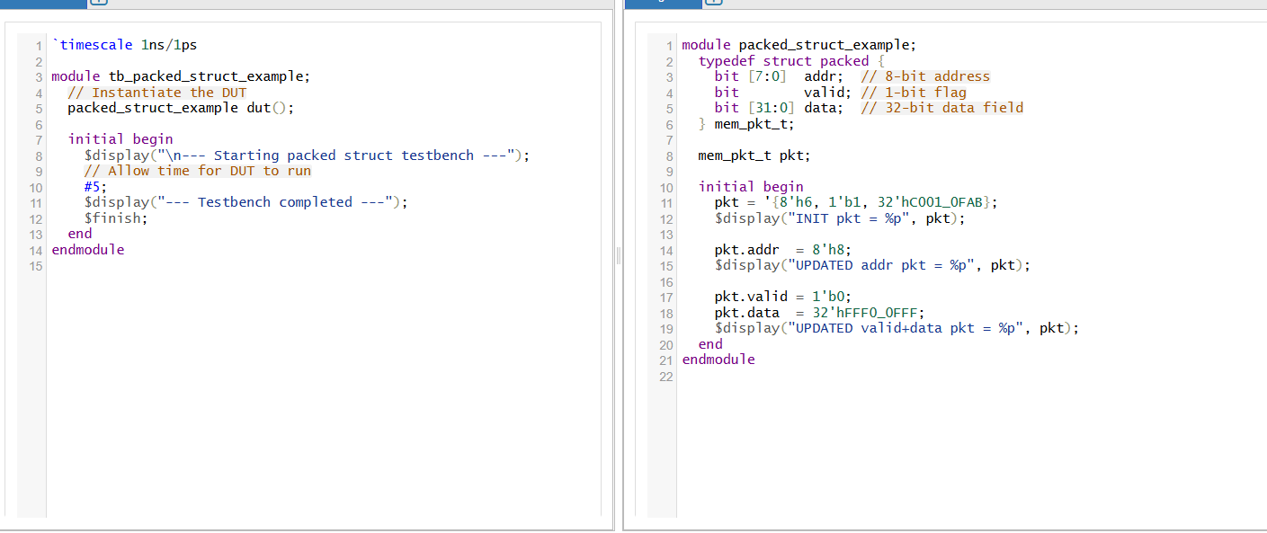
# KERNEL: INIT pkt = '{addr:6, valid:1, data:3221295019}
# KERNEL: UPDATED addr pkt = '{addr:8, valid:1, data:3221295019}
# KERNEL: UPDATED valid+data pkt = '{addr:8, valid:0, data:4293922815}

🎯 What is a Packed Struct?
A packed struct packs multiple bitfields contiguously into a single vector—much like defining bitfields in C—making it ideal for hardware-oriented representations such as registers or bus packets. Declared using typedef struct packed { ... } name;
- All members must be packed data types like bit, logic, or enums—no dynamic types like string.
- The ordering is MSB first: the first member defined occupies the most significant bits, and subsequent members fill lower bits.
🧠 Why Use Packed Structs?
Feature | Packed Struct
Memory layout | Dense, no padding—like a single bit-vector packed tightly.
Bitwise operations | Supports treating the whole struct as a vector—allows slicing, merging, or vector assignment.
Hardware-friendly | Perfect for representing hardware-level interfaces (e.g., protocol frames or register maps).

🔧 Key Properties
- Contiguous, gapless layout
All fields follow in memory exactly in sequence, forming a compact vector.
- Vector equivalence
Since it's like a bit-vector, you can assign it directly:
- Bitwise slicing/concatenation
Enables easy read/write of sub-fields or bundling with other vectors.
- Type restrictions
  - Only packed data types allowed (e.g., bit, logic, enums).
  - No string, dynamic arrays, etc.
  - Packed structs are unsigned by default, though you can add signed if desired.

🏁 Summary
- Packed struct = tight, vector-like representation of multiple fields.
- All fields are contiguous and directly accessible at both field-level and whole-vector level.
- Ideal for synthesizable hardware constructs—registers, bus frames, protocol descriptors.
- Not suited for dynamic or mixed-type data storage—use unpacked structs or other data structures in those cases.

Day 64: Array
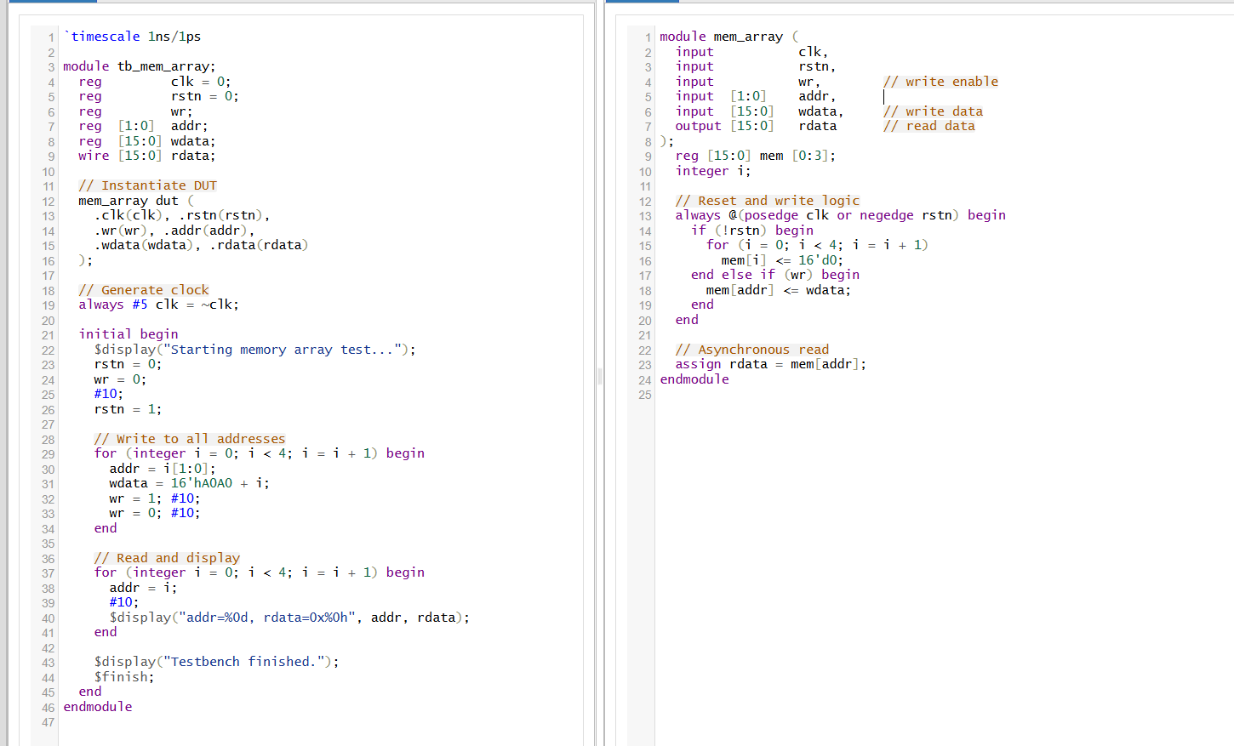
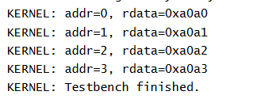
🧠 Theory Behind the Design
1. Memory Modeling in Verilog
- Declaration:
verilog
CopyEdit
reg [15:0] mem [0:3];
Models a simple 4-word × 16-bit memory using a one-dimensional reg array. Each index corresponds to a separate 16-bit location – similar to small RAM or register file in hardware.
  - On active‐low reset (rstn == 0), all memory entries are cleared synchronously at the rising edge of clk.
  - When wr is asserted, the new write data (wdata) is stored into mem[addr] on the next clock pulse.
This is a typical method to reset and write memory in hardware—each memory cell is implemented using flip-flops. Asynchronous
Continuously outputs the memory content at address addr, without waiting for a clock. A combinational read path is common in many memory structures, though FPGA block RAMs may enforce synchronous read only.
Reset & Write Sequence:
  - Reset is held for 10 ns at start to initialize all memory cells to zero.
  - A loop writes unique data (e.g., 16'hA0A0 + i) to each address 0–3, with proper handshake between write enable (wr) and clock cycles to ensure timing.
- Read Cycle & Verification:
  - After writing, the testbench cycles through each memory address.
  - Captures and displays data for comparison to confirmation.
This style—writing known patterns and reading them back—is the basis of functional verification.

Synchronous vs Asynchronous Access
- Synchronous Write + Reset: Ensures data is only changed on clock edges, reducing timing hazards and guaranteeing deterministic behavior. Every memory bit changes in sync with clk.
- Asynchronous Read: Offers immediate visibility of stored data when addr changes. This can simplify debugging, but may limit mapping to block RAM in some FPGA architectures.

Day 65: Functions
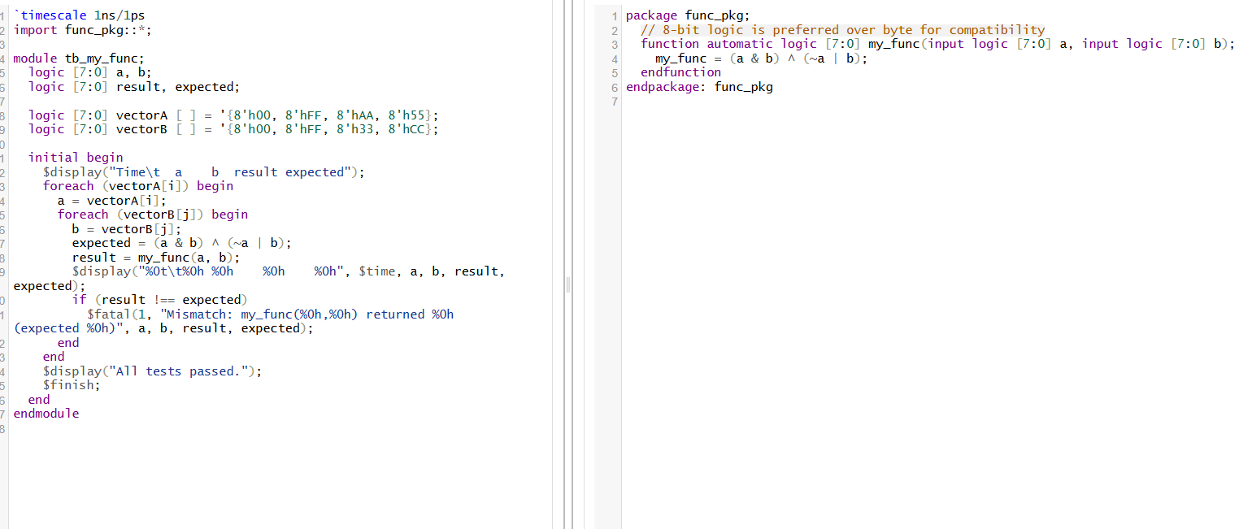
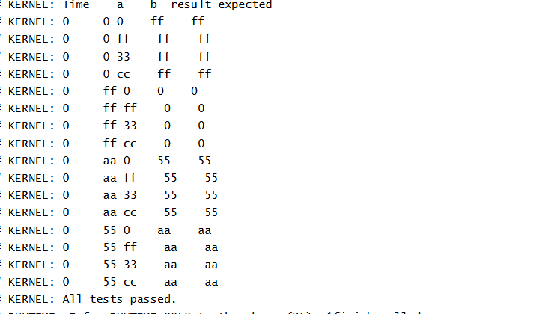

📦 1. SystemVerilog Package (func_pkg)
- Purpose: A package allows you to declare functions, tasks, types, and parameters in a shared namespace, enabling code reuse across multiple modules or
- This wraps your combinational logic in a globally accessible container. Import it using:
This eliminates duplication and clarifies scope .

🔢 2. Combinational Function (my_func)

- function automatic logic [7:0] my_func(...):
  - Declares a pure combinational function returning an 8-bit logic type.
  - automatic ensures reentrancy and thread safety, preventing shared state across invocations.
  - Using logic [7:0] is preferable for synthesis compatibility over byte.
- Function Body:
This is a single, blocking assignment that ensures all bits are assigned in all execution paths—avoiding accidental latch inference

🧰 3. Dynamic Arrays (vectorA, vectorB)
  - [] signifies a dynamic unpacked array: its size is determined at runtime
  - The '{'...'}' initializer synthesizes and populates the array at elaboration.
- Benefits:
  - Flexible sizing and initialization.
  - Supports operations like .size(), .delete(), new[N], and copy-on-resize
🔁 4. foreach Loop

  - Automatically iterates over all valid indices of vectorA—clean, safe, and avoids off-by-one errors .
  - SystemVerilog handles this elegantly even for multi-dimensional arrays
🧠 5. Combinational Logic in Testbench
- The function call result = my_func(a, b); re-evaluates logic instantaneously—no time control statements or events used.
- Since it's invoked inside an initial block (without always_comb), you're manually stepping through test cases without relying on event-driven simulation semantics.

Day 66: Task
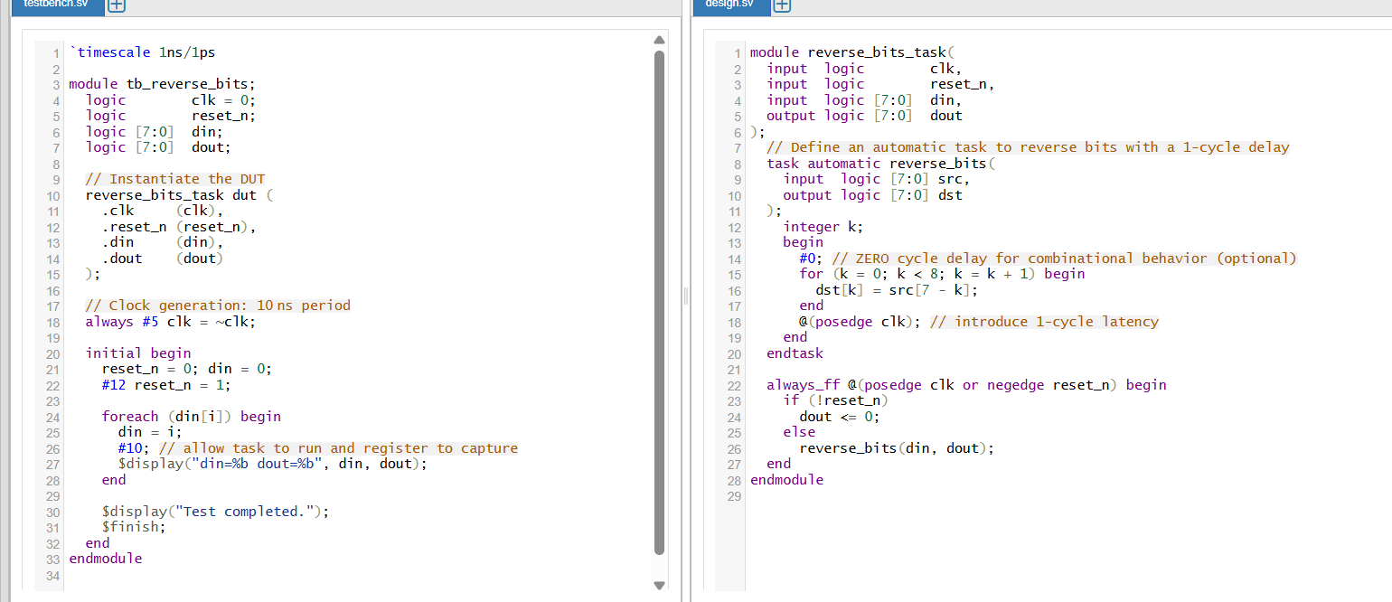
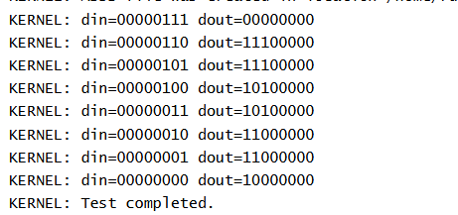
🔁 1. Task vs. Function
- Tasks:
  - Can include time controls (#delay, @event) and multiple outputs via output/inout ports
  - Allow blocking of simulation time, e.g., @(posedge clk).
  - Default to static storage, meaning variables persist across invocations; adding the automatic keyword makes them re-entrant, allocating fresh memory per call
- Functions:
  - Must execute within zero simulation time and cannot contain delays or event controls
  - Return a single value, and their return value can be used directly in expressions
🧠 2. Why Use a Task Here?
- If your design involves timing, multi-output operations, or stepwise processing (e.g., in RTL pipelines), tasks are the right choice
- Tasks encourage modular, readable, and reusable code, especially when the code isn't pure combinational and spans cycles
📚 3. Key Properties of Tasks
Feature | Task | Function
Timing controls | ✅ allowed | ❌ forbidden
Multiple outputs | ✅ via output/inout | ❌ only single return
Zero-time execution | No | Must complete in zero time
Storage type | static default, automatic for per-call memory allocation | variables are local and per-call
Reentrancy | Only if automatic | Always reentrant
Can be part of synthesis? | Yes, if no delays used | Yes

🧩 4. automatic Keyword in Tasks
- Declaring a task as automatic ensures local variables are freshly allocated every time the task is called—even if calls occur concurrently via fork/join .
- Without automatic, tasks share state across calls, which can lead to unintended interference in concurrent scenarios.

Day 67: Interface
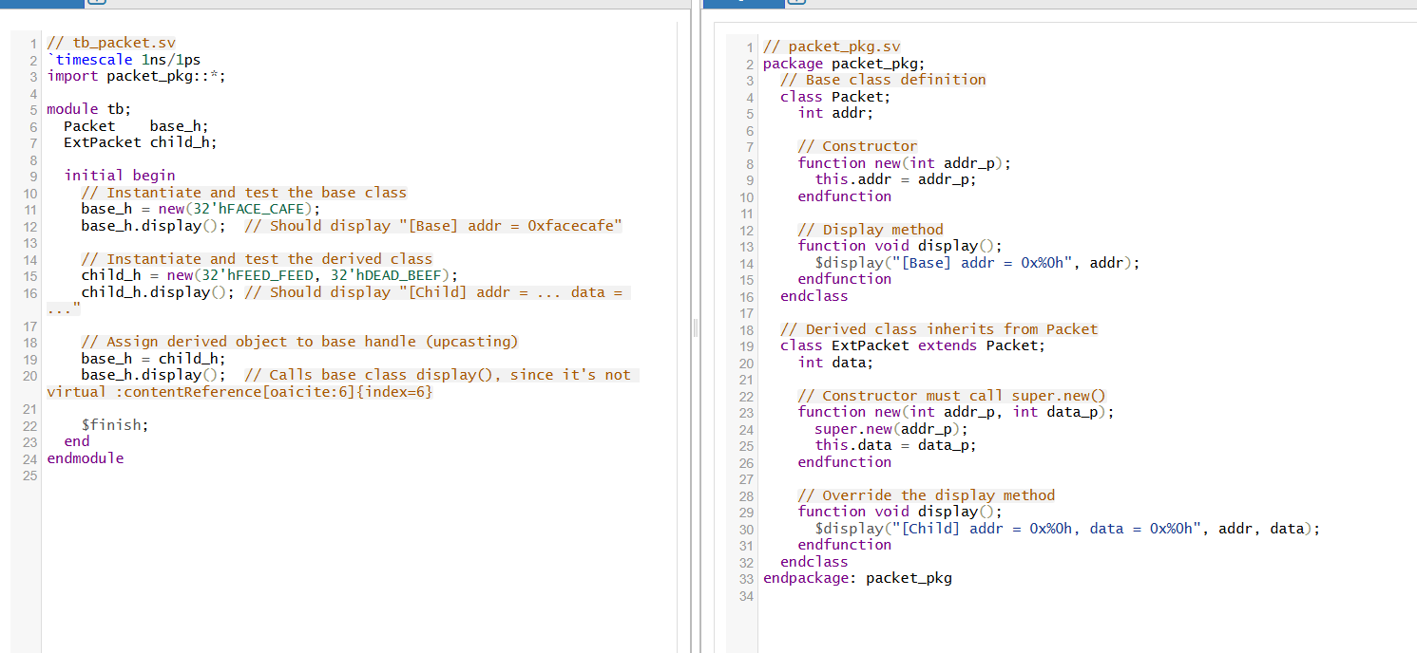
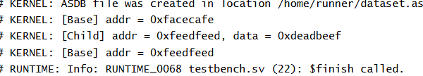

🧬 1. What Is Inheritance?
Inheritance in SystemVerilog’s object-oriented paradigm allows a derived class to automatically gain the properties and methods of a base (parent) class, while also being able to add new members or override existing ones It promotes code reuse, modularization, and extensibility, enabling you to extend functionality without altering the original base class.

🔁 2. Extending vs. Overriding
- Extending: A derived class may introduce new variables and methods not present in the base class.
- Overriding: The derived class can provide its own implementation for methods inherited from the base class. However, unless marked virtual, calls through a base-class handle will still invoke the base version.
🧠 3. Constructor Chaining
SystemVerilog requires explicit calls to a parent’s constructor if it has parameters. The derived constructor uses super.new(...) as its first action, ensuring proper initialization of inherited members If no constructor is defined explicitly, SystemVerilog generates a default that chains automatically.

⚙️ 4. Polymorphism & Virtual Methods
- Upcasting: A derived object can be referenced by a base-class handle, enabling generic code usage
- Dispatch behavior:
  - Non-virtual methods: Resolved statically at compile-time — always invoke the base implementation when called via a base handle.
  - virtual methods: Support dynamic dispatch, executing the derived-class version even through a base-class refeerence

🔄 5. Multi-level Inheritance & super
Inheritance can span multiple class levels. The super keyword lets a derived class explicitly call its immediate parent’s implementation—useful when overriding but still wanting base behavior included .

Day 68: Inheritance
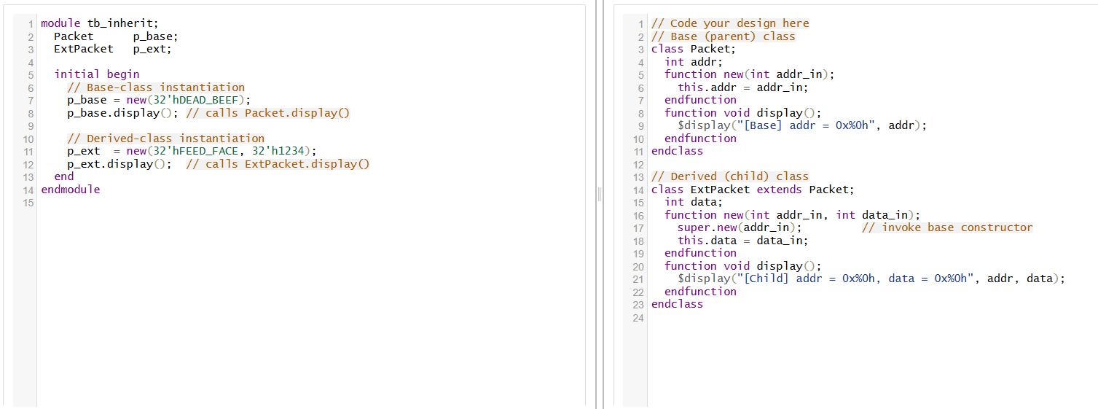
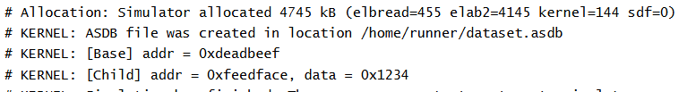

1. Inheritance
Inheritance in SystemVerilog lets you define a derived (child) class that extends a base (parent) class, inheriting its data members and methods. The derived class can:
- Reuse existing features without touching the base.
- Add new members or override existing behavior
Key points:
- Only single-inheritance is allowed; multiple parent classes aren’t supported
- Multilevel chains (a child of a child) are supported

2. extends Keyword
Use class Derived extends Base; to set up the inheritance relationship.
This provides:
- Access to all accessible members from the base class.
- Seamless integration of new and overridden members in the child
3. Method Overriding & super
- Override a base method by declaring it again in the derived class.
- Use super.method() to call the parent version from within the override, preserving base functionality 4. Constructors and super.new()
- Each class can have its own function new(...).
- If the parent defines new(...), the child’s constructor must explicitly call it via super.new(args); as the first statement
- If not explicitly declared, SystemVerilog automatically chains constructors and calls the base one.

5. Polymorphism with virtual
- Declaring a method virtual in the base class enables dynamic dispatch.
- A parent-class handle pointing to a child object will execute the child's overridden version of the method at runtime
- This is key for writing flexible, extensible testbench code.
6. Dynamic Casting ($cast)
- Up-casting (child → base) works implicitly.
- Down-casting (base → child) requires using $cast(child_handle, base_handle), which returns success/failure.
Useful for accessing child-specific fields from a base handle

Day 69: Polymorphism
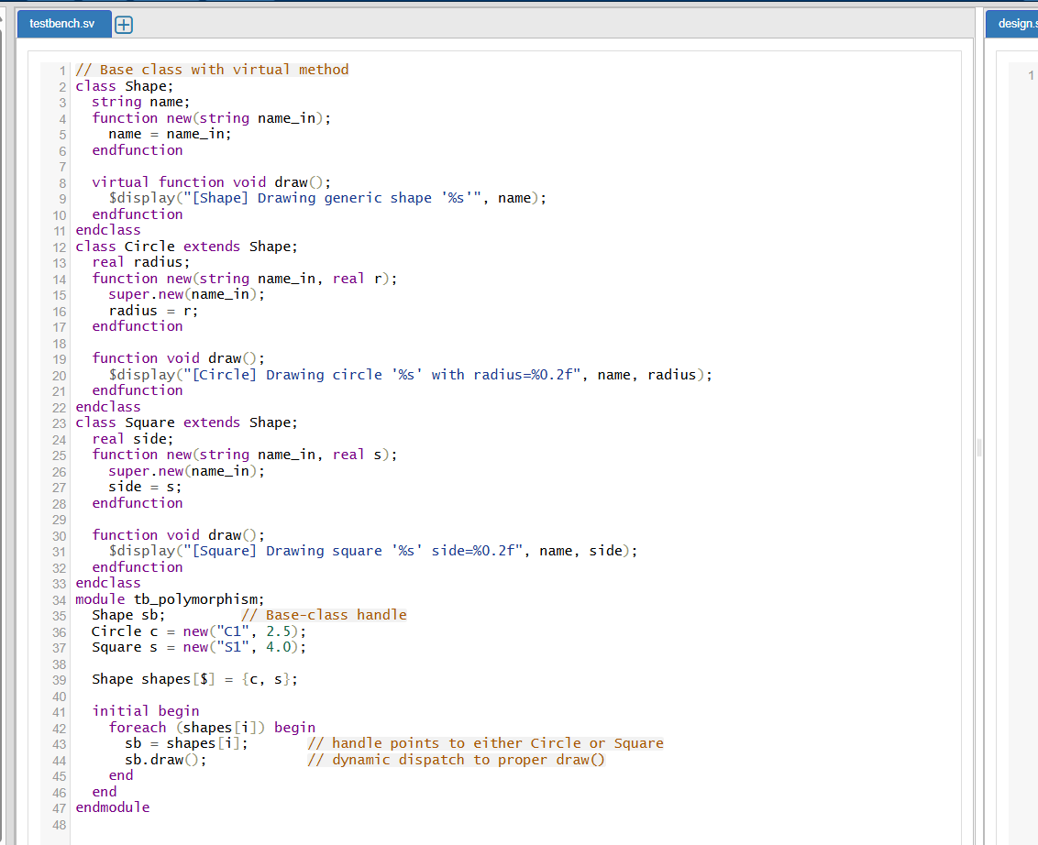
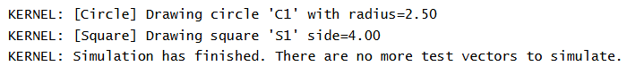
🧠 What Is Polymorphism?
Polymorphism — literally “many forms” — enables a base-class handle to refer to objects of different derived classes, and invoke their specific behaviors at runtime rather than compile time. In SystemVerilog, this is achieved using virtual methods within a class hierarchy

🔍 Key Concepts in SV Polymorphism
1. Virtual Methods
Declaring a function or task as virtual in the base class signals that derived classes may override it. This transforms the method call into a late-bound operation, allowing correct override execution during simulation
2. Polymorphic Handles
When a base-class handle (e.g., Shape sb) references an instance of a derived class (Circle, Square, etc.), a call to a virtual method on the handle resolves to the overridden implementation in the actual object class
3. Dynamic Dispatch
SystemVerilog uses a mechanism akin to a vtable (virtual method table). At runtime, the simulator selects the correct method version based on the object’s actual class type—not just the declared type of the handle
4. Up and Down Casting
- Up-casting (derived → base) is implicit and safe — e.g., assigning Circle to a Shape handle.
- Down-casting (base → derived) requires using $cast(child_handle, base_handle). This returns true if the conversion is valid at runtime and prevents type incompatibility issues

💡 Why It's Useful
✅ Code Reuse & Extension
Base classes can define broad interfaces (like a generic draw()), while derived classes customize the implementation. This encourages modular, extensible design.
✅ Flexible Testbenches
In environments like UVM, many components (like sequences and drivers) rely on polymorphism to handle various subtypes using a unified interface
✅ Runtime Selection
Tests or configurations can choose at runtime which subtype to instantiate—without changing hierarchical code—simply by using polymorphic handles.

Day 70: Parametrized Class
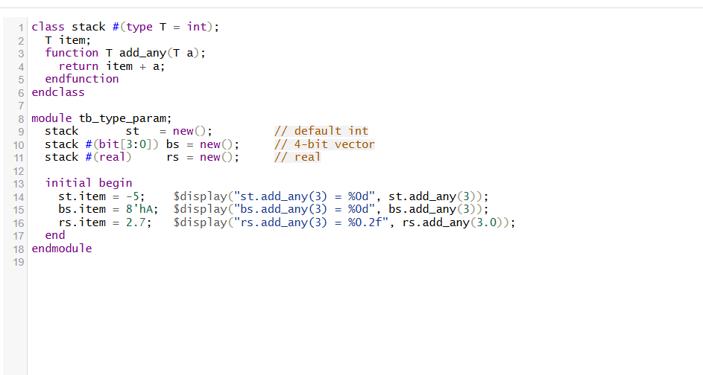
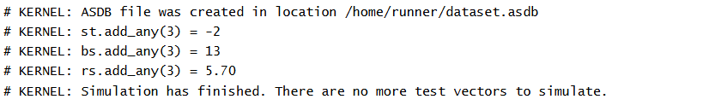

🎯 What Are Parameterized Classes & Why Use Them?
Parameterized classes are like templates in C++. They let you define a generic class blueprint that can be specialized at compile time by providing values or types. The combination of the class name and its parameters forms a unique class specialization.
Why they're useful:
- Promote code reuse and reduce duplication—for instance, building FIFOs or transactions of various widths or types from a common template.
- Provide compile-time flexibility, enabling different behavior or storage depending on parameterization.

🔧 Types of Parameters
- Value Parameters (int SIZE = 8):
  - Define fixed constants or widths.
  - Example: something #(int size = 8) allows instantiation with different size values. Each distinct size creates a new class specialization
- Type Parameters (type T = int):
  - Allow the class to operate generically over different data types.
  - Example: stack #(type T = int) can be instantiated as stack#(bit[3:0]) for 4-bit vectors, or stack#(real) for real numbers

🧱 Class Specialization & Type Safety
Each unique parameterization defines a distinct class type. A handle for something#(8) is not compatible with something#(16)—they are separate classes

📝 Constructor Behavior
Unlike some templates in other languages, all parameters—value or type—must be known at elaboration time, before simulation. You cannot pass parameter values or types dynamically at runtime; they’re fixed when you declare the object specialization
🔄 Inheritance & Parameterized Classes
Parameterized classes integrate gracefully with inheritance. You can extend a parameterized class directly, or pass its parameters along to the base. This enables layered generic design patterns
✅ Summary Table
Feature | Description
Value parameter | Customize constants like bus widths
Type parameter | Generalize class for different data types
Specialization | Each unique parameterization produces a new class
Compile-time binding | Parameters fixed during elaboration
Inheritance-compatible | Can extend parametrized classes, pass along parameters
UVM relevance | Core to reusable, typed sequences, agents, transactions



